Task: Create a Hobby Tracking Application as part of a collection of Hobby applications.

Action: Over the course of two weeks, I built a Personal Hiking Application, “Personal Hiker” for users to create and log trails they have completed. Additionally, I added a built-in weather API to check the current weather conditions where the user is located.

Solution: Python and Django via PyCharm

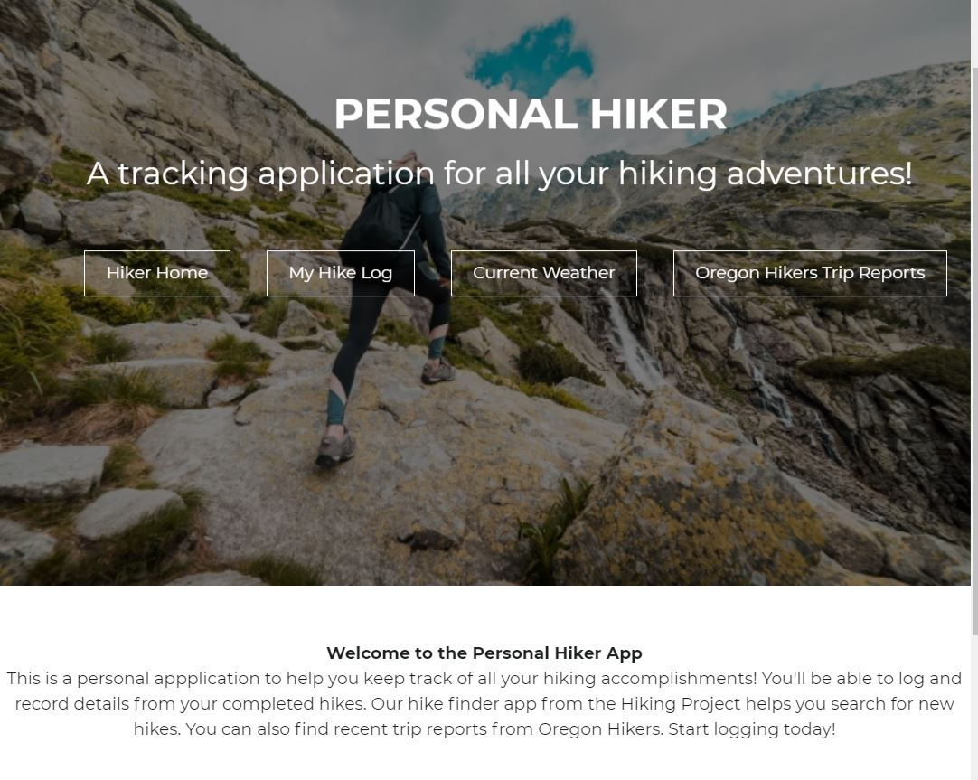

Below is the Hiker Log page. This will show a collection of hikes the user has logged using the Create Hike page. This was styled using html/css and coded using the model and views features in Django.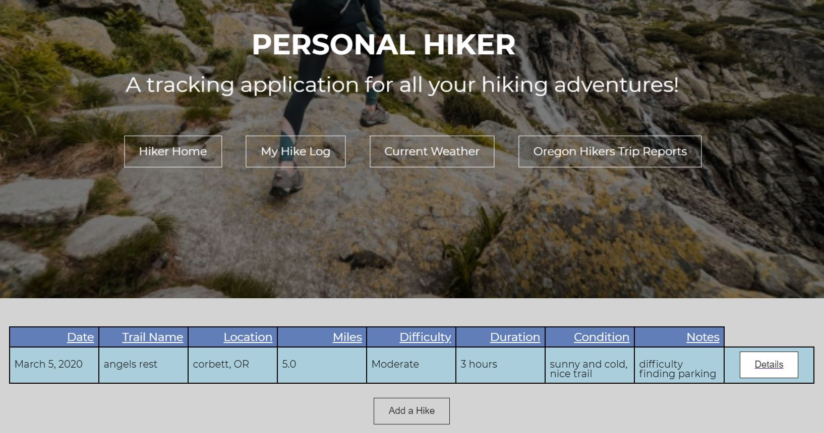

Below is the Edit/Add hike page.

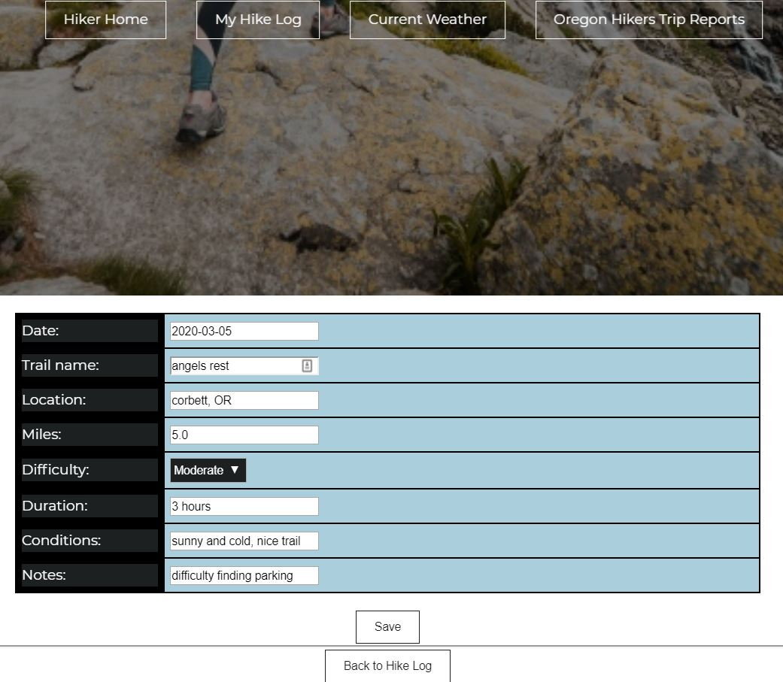

Below is the API I added to get the users current weather conditions. It automatically grabs the location of the user’s IP address and feeds that into the Weather API to give the user customized weather conditions.

